DIGITIZATION

OF THE

RENEWABLE

ENERGY SECTOR

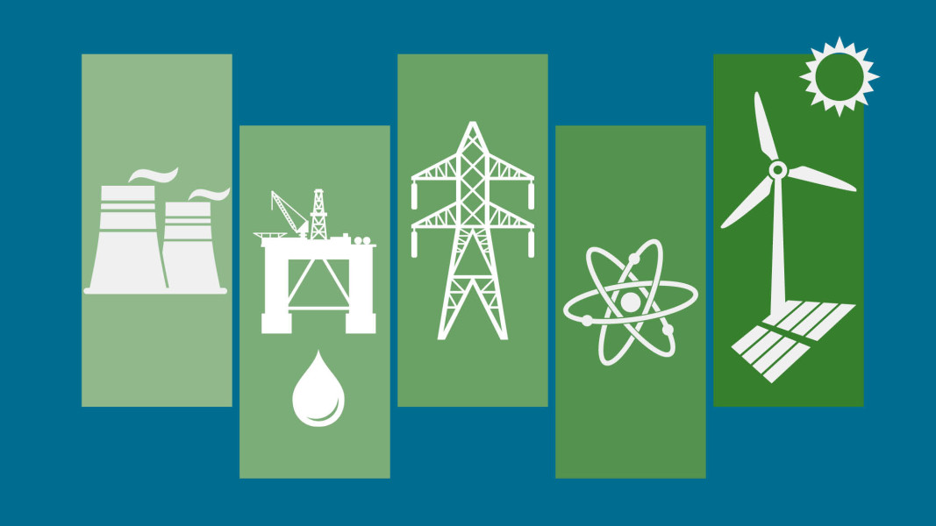

Presented by -

Rohit Anand

Msc Data Engineering

Current Topics in Data Engineering 2019

**1. ABSTRACT**

The lack of data about energy usage has led to inefficiencies. Every year, the electricity being lost around the globe can be enough to power German, India and Canada for a year. To analyze the data being collected from outside sources is a challenge for industries.

The scope for efficiently gathering and analyzing the data from various sources of energy has been a challenge. This report takes a peek towards the importance of Big Data and IoT in the field of energy. Mostly towards how the data is collected and analyzed by the industries. Field of coverage includes renewable energy resource generation and consumption, specifically in India, and also the various technologies used.

By analyzing the current trend in the energy sector, we will be able to gain insight upon the opportunities for extracting data from smart meters and outside sources and utilizing them for advanced analytics.

**2. INTRODUCTION**

Today’s energy sectors are in a phase of changing landscape – data is the key to this change. Evolving technologies in this sector can provide immense capabilities for forecasting energy demand, monitoring usage patterns, avoiding power outages and more. At the same time, these advancements generate overwhelming volume of data with complexity. To utilize this information to gain insights, energy and utility companies are seeking to big data technologies capable of high-volume data management and advanced analytics.

Many countries have opted for significant solar power capacity and wind turbines into their electrical grids as an alternative of non-renewable source of energy. Solar power plants may use one of the below technologies – Photovoltaic systemns(PV) for direct coversion and Concentrated solar power(CSV) to make steam and then convert it to electricity. Since 2010 half of the new wind turbines and smart farms was installed in Europe and North America with a increasing demand in China and India.

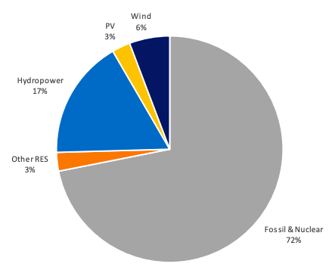

*[4] Share of PV and Wind energy in the Global Electricity Demand 2018*

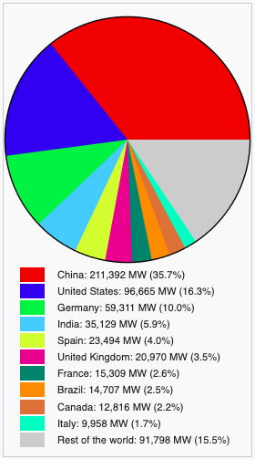 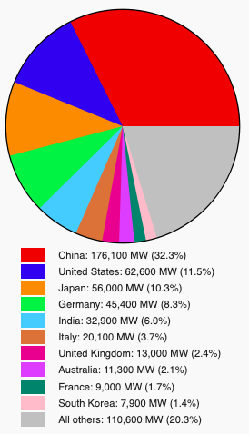

*[5] Installed capacity for wind turbine* *[6] PV installed until 2018*

Internet of Things (IoT) is a growing field in the research and development and for real applications. Lee [1] classified IoT as an industrial Internet, since it is going to change today’s computing paradigms and trigger new business models in order to satisfy industries and market needs. IoT is a concept where automated services are created making the smart devices fully accessible to the operators. IoT standardizations are currently being developed by advanced technical organizations such as IEEE. In the United States, companies like IBM indicate that the Internet of Things is a field of interest to improve technology infrastructure, and Japan also has shown strategies to create smart city standards [2]. IoT is the new future.

Big Data concepts become handy while handling huge volume of data. Data from a source generally is generally unstuructured. We can leverage big data concepts to extract this data and process it using efficient algorithms and store in a structured format. Hadoop framework is one of the most utilized concepts for this purpose. Structured data stored in cloud can then be used for predictive analytics to forecast maintenance service or failure risk.

Installing and maintenance of wind turbines or solar panels comes with challenge. Sources of wind and solar can be unpredictive because of its dependency on the changing weather conditions. Poor quality of data derived from source systems, cost control, system stability and other challenges can become a major tasks to overcome.

Visualization

Analytics

Data processing

Data Acquisition and transmission

*Flow of information*

**3. IMPLEMETATION**

This section presents the application of big data analytics which may be used to to monitor and forecast the power generation of solar or wind farms. The infrastructure shall allow data ingestion, processing, storage and analysis of real-time statistical information through an user interface. This might change the energy production pattern and consumption. Using big data techniques, smart grids can anticipate failures rapidly, provide economical way of producing power and give more control of electricity consumption the the consumers. These techniques become handy in integration of renewable energy into the smart grid.

The concept of Big Data revolves around the 5 Vs:

*Volume*

Massive amount of data generated by IoT devices installed in various components

*Variety*

Unstructured data: Consumer behaviour or audio or video data

Semi-structured data: Weather data

Structured data: In a tabular/readable format

*Velocity*

The speed of data generation from smart devices which may vary from nano-seconds to minutes

*Veracity*

The trustworthiness of data.

The data should be accurate and reliable.

*Value*

If the data is really worth the technological investment.

The benefits[3] of implementing big data are –

* Better decision making with reliable information
* Dynamic and flexible way of delivery data through components.
* Detailed information about the process of generating electricity through analysis of training set and test set data.

Big data and architecture consists of different dymensions and logical layers[3].

*Infrastructure*

Physical infrastructure – hardware, network and other elements

*Data Sources*

Format, Volume and Velocity, Acquisition of data and Location of data source

*Data Ingestion, Processing and Storage*

Transform data in a readable format for analysis

*Analysis*

Entity identification, Engine, Statistical Models Management

*Monitoring and Visualization*

Real-time monitoring, Recommendation Engine

**3.1 DETAILED FLOW OF INFORMATION**

Simulator to generate real-time data(Power, current, voltage, etc.) with a frequency of 10 seconds

Dashboard and visualization interfaces provide users with the ability to undestand data and make decisions

Alerts are generated on dashboards and emails fort he above processes.

The processed data is sent to HBase database which stores data in files and sends it tot h HDFS

Measurements of variables are validated to detect a failure

Spark Stream processes data through algorithms which calculate statistics.

Spark Stream acquires data from MOM and sends it to the clusters. Data can be divided into batches.

Simulator sends data to MOM, Message Oriented Middleware which sends data to Spark Streaming

**3.2 IoT ARCHITECTURE**

The concept of IoT is to provide Internet for any device to make it easy for the devices to exchange information with the servers. IoT can be categorized as – i) data collection from control panels to track variables and performance in real-time and ii) big data where it is based on sensors that allow to generate large scale data. Systems are based on an IoT infrastructure, containing the framework, that will analyze the signals from the sensors installed in source components and send information about the status ot the devices connected to the network.

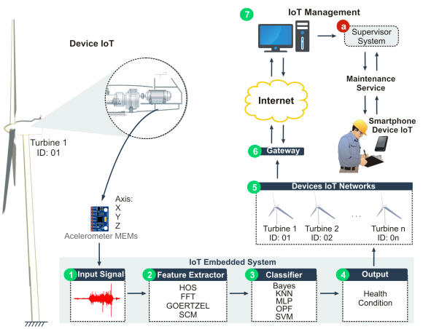

*[7] Proposed by IECS*

Data acquisition systems tracks the signals for some interval of time (~10 sec). The embedded systems contain the Feature Extractor and the Classifiers.

**3.3 FEATURE EXTRACTION**

Single or a fusion of feature extraction methods can be used to compose data sets to be send to

the classifiers to make predictions. The main purpose of feature extraction method is to reduce the dimensionality of the the data sets and filter the necessary data from the data set.

Three methods were proposed by Sousa, pedro H. Feijó[7]:

1. Higher-order Statistics (HOS)
2. The Fourier Transform
3. The Structural Co-occurance Matrix (SCM)

One single dataset was generated by each feature extraction method and then fed into classifiers. Fusion of these feature extraction methods were created to increase the dimensionality of the problem.

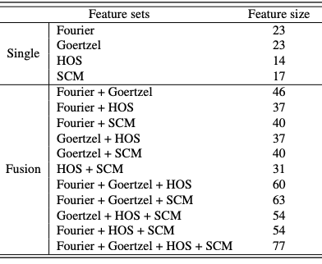

*[7] Single and fusion of feature extraction of methods and their dimensionality*

**3.4 CLASSIFIERS**

After the feature extraction step, a few datasets are created which are forwarded for preprocessing. Normalization is done on the data sets using mean zero and unit variance.The accuracy and confusian matrix are used as metrics to evaluate the performance of the classifiers for forecasting results. The goal is to evaluate the performance of different classifiers with various feature extraction methods.

Naïve-Bayes classifier: classifies on the basis of density functions

SVM: determines the class of samples with limits that increase the distance between them.

MLP: non-linear vector in the input vector and another vector in the output vector

OPF: classifier based on graph theory

KNN: distance based classifier

RBF: Radial basis function

Accuracy: the most successful / extractor combination

Confusion: the extractor / classifier combination sets

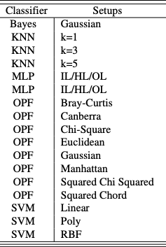

*[7] The best configurations for the classifiers*

**4. PREDICTIVE ANALYTICS**

Better forecasting grid conditions are required with the increase in smart farm installations for

the wind and energy resources. To be able to address the ever-changing grid challenges, operators need to enhance their capabilities in monitoring, predicting and estimating resource adequecy and demand fluctuations. When all of new sensing technologies, such as inverters and electric vehicle charging stations, are adopted in large numbers, it creates an enormous volume of data at finer scales which can be difficult for the power operators to monitor upon. Big data analytics play an important role in this situation to estimate and predict the system conditions.

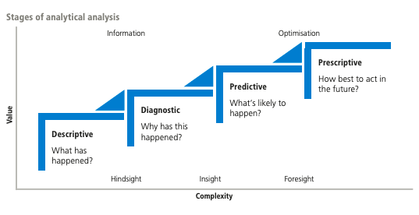

*[15] Stages of analytical analysis*

Predictions help determine the maintenance schedules and procedures that have the least impact on production. Based upon these recommendations maintenance personnel can then generate work orders. Predict potential asset degradation or failure. Predicitve model generator generates predictive models for each wind turbine/ solar panel /heliostat and other components. Monitoring agent for making predictions using the generated models at fixed time intervals[16].

It is important to improve the accuracy of predictions of wind and solar energy that is used in power system scheduling because of their uncertain nature of availability. This report will give an overview of the various methods for forecasting the energy resources.

Wind forecasting models can be generally classified into three groups [8]: i) physical models based on numerical weather prediction models(NWP) ii) statistical methods based on data-driven approaches iii) hybrid(fusion) of physical and statistical models. NWP models can be divided into Global Models (GMs) and Limited Area Models (LAMs) based on the domain coverage [9-11]. To fulfill forecasting needs, serveral GMs have been deployed such as Global Forecast Systems (GFS) and Integrated Forecast Model. More high resolutions are provided by LAMs when compared to GMs. Due to the fact that NWP Models take a longer time to run, statistical models are preferred for short term forecasting. Among the non-linear models, (Support Vector Machine) SVM and (Artificial neural Networks)ANN are used for wind forecasting.

Wind Forecast Improvement Project (WFIP)[12] was executed to enhance the short term wind power predictions.

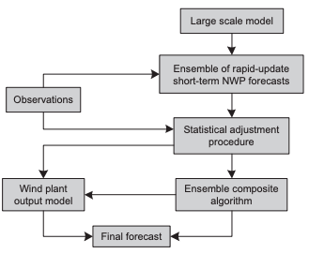 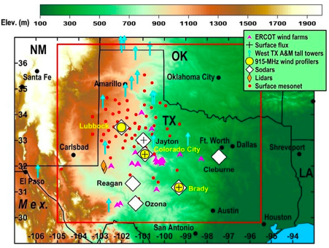

*[12] Model for wind forecasting system(WFIP) [12] WFIP study Region*

With the increasing solar power penetration in many areas around the globe, it has become necessary for advanced solar predictions for electricity system operations. Substantial economic loss may be incurred due to solar forecast inaccuracies along with power system reliability issues.

Researchers have developed many data driven predicting techniques such as the NWP model, tracking cloud movement through satellite images and ground based cameras, and statistical approaches using historical data[13].

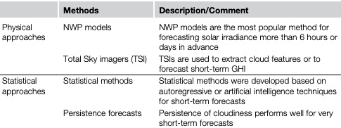

*[14] Solar Forecasting Methodologies*

**5. CURRENT UTILIZATION OF RENEWABLE ENERGY RESOURCES IN INDIA**

Solar power industry in fast developing with the advent of new technologies. As of 31 October 2019, the solar installation capacity increased to 31.696 GW which was achieved four years ahead of target date[17]. India has sanctioned 42 solar farm areas to encourage the promoters of solar plants according to MNRE. The government has taken initiatives to expand its grid connected photo voltaic along with installation of off-grid solar power for local energy needs.According to the Economic Times Report[18], about a million of solar lanterns were sold in rural areas which reduceed the dependency on kerosene oil.

The solar energy available in India in an year, exceeds the energy outputs of all resources of fossil fuel. The estimated incidence of solar rays is about 5000 trillion Kilowatt-hours per year.

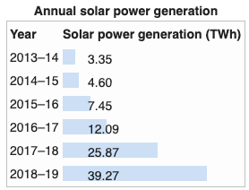 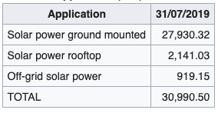

*[19] Annual solar power generation in India [17] Photovoltaic Instllations in India*

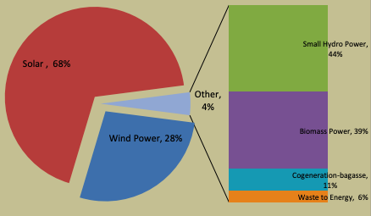 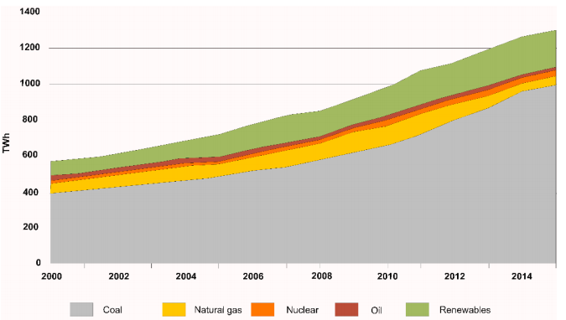

*[20] The total estimated potential for renewable [25] Electricity Production in India from*

*energy as on 31.03.18 is 1096081 MW different sources*

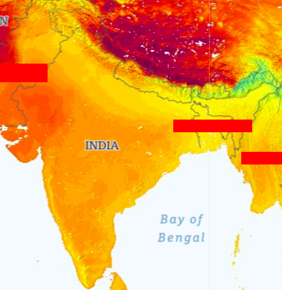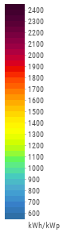 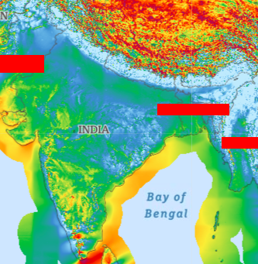*Global Solar Atlas (Photovoltaic power output)* *Global Wind Atlas(Mean Wind Speed)*

Wind power generation has increased rapidly in India. The total installed wind power capacity was 36.625 GW as of 31.03.2019. The wind power is spread across almost all over India, most concentrated in the Southern-West region. Wind power costs in India is decreasing rapidly with the announcement of tariff-based auctions to bring more clarity and minimize the risk for the developers.



*[23] Wind power capacity installation and generation in India*

In 2013, the project called Facilitating Offshore Windpower in India(FOWIND) was started by Global Wind Energy Council(GWEC) to identify potential off-shore areas in India to extract wind power.

Initiatives taken by the government of India to promote the develepment of renewable energy sector- In 2016, the Prime Minister of India and the President of France laid a foundation for International Solar Alliance(ISA). The focus of this council is to promote the development of solar products and energy for the country lying wholly or partly between the Tropic of Cancer and the Tropic of Capricorn. It was launched at the Paris COP21 Summit with an alliance of 120 countries. A memorandum has been issued by the Ministry of New and Renewable Energy to ensure the quality of solar cells[24]. Non-profit organizations – Indian Wind Power Association (IWPA) in 1996 and Indian Wind Energy Association (InWEA) in 2002.

Targets setup-

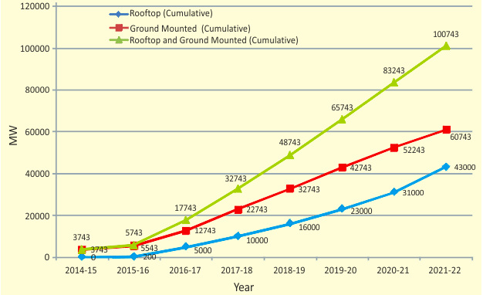

*[26]Solar power Target*

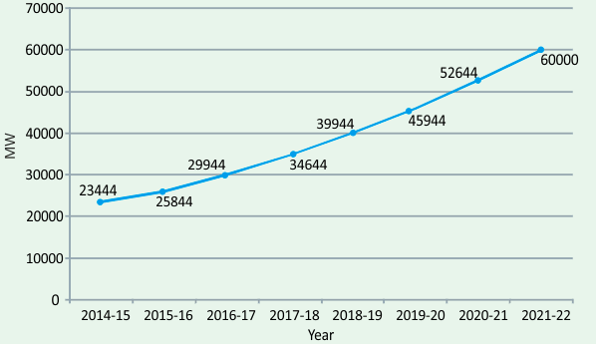

*[26] Wind power target*

**6. CONCLUSION**

As energy consumption increasing worldwide, renewables can be out of sync sometimes. Relying totally on renewables without proper management can inefficient storage and usage. Data analysis plays an important role with ability to monitor this and control the energy consumption and predict outages.This can be achieved using hybrid source of power, optimzing the energy mix and using optimal artifical intelligence and machine learning algorithms

The use of smart grids and analytics is crucial for smooth functioning of a smart city and its infrastructure. Running IoT devices also require continuous electricity which can be supplied through installion of solar panels. To keep the infrastructure synced, the IoT devices and cloud computing plays a major role which required efficient management of electricity. Smart and ditized solutions can monitor devices and keep a track of power requirements and consumptions. Achieving this requires data extraction from sensors to be simplified along with using regressions, machine learning and artificial intelligence to determine relationship between event/outcome, uncovering patterns in sensor data and learn independently responding to environmental stimuli respectively.

In the future, digitized energy solutions might be able to identify the energy requirements of the end user, deliver it in the right place and in the right time with the lowest possible cost. Digitalization could reduce energy usage in commercial and residential buildings by around 10% by 2040. These efficiency gains are largest in heating and cooling sectors, particularly through the use of smart thermostats and sensors.

**7. RESOURCES**

[1] In Lee and Kyoochun Lee. The Internet of Things (IoT): Applications, investments, and challenges for enterprises. Business Horizons, 58(4):431–440, 2015.

[2] Li Da Xu, Wu He, and Shancang Li. Internet of things in industries: A survey. IEEE Transactions on Industrial Informatics, 10(4):2233–2243, 2014

[3] Guillermo Escobedo, Norma Jacome and G. Arroyo-Figueroa : Big Data & Analytics to Support the Renewable Energy Integration of Smart Grids

[4] ["IEA PVPS Snapshot of Global PV 2019"](http://www.iea-pvps.org/fileadmin/dam/public/report/statistics/IEA-PVPS_T1_35_Snapshot2019-Report.pdf) (PDF). *IEA*.

[5] <https://gwec.net/wp-content/uploads/2019/04/GWEC-Global-Wind-Report-2018.pdf>

[6]<http://www.iea-pvps.org/fileadmin/dam/public/report/statistics/IEA-PVPS_T1_35_Snapshot2019-Report.pdf>

[7] [https://iecscience.org/uploads/jpapers/201906/sjx4PlAqBWaNu0V2ZtygEdEatT6cdBBSEO  
f12snF.pdf](https://iecscience.org/uploads/jpapers/201906/sjx4PlAqBWaNu0V2ZtygEdEatT6cdBBSEOf12snF.pdf)

[8] ] J. Mendes, J. Sumaili, R. Bessa, H. Keko, V. Miranda, A. Botterud, Z. Zhou, Very short-term wind power forecasting: state-of-the-art, Tech. Rep., Argonne National Laboratory (ANL), 2014.

[9] N.P. Wedi, P.K. Smolarkiewicz, A framework for testing global non-hydrostatic models, Q. J. R. Meteorol. Soc. 135 (639) (2009) 469–484.

[10] J.J. Traiteur, D.J. Callicutt, M. Smith, S.B. Roy, A short-term ensemble wind speed forecasting system for wind power applications, J. Appl. Meteorol. Climatol. 51 (10) (2012) 1763–1774. [8] J. Cot ^ e, S. Gravel, A. Methot,

[11]A. Patoine, M. Roch, A. Staniforth, The operational CMC-MRB global environmental multiscale (GEM) model. Part I: design considerations and formulation, Mon. Weather. Rev. 126 (6) (1998) 1373–1395

[12] J. Zhang, M. Cui, B.-M. Hodge, A. Florita, J. Freedman, Ramp forecasting performance from improved short-term wind power forecasting over multiple spatial and temporal scales, Energy, 122 (2017) 528–541.

[13] Yingchen Zhang*, Rui Yang*, Jie Zhang† , Yang Weng‡ , Bri-Mathias Hodge*

Predictive Analytics for Comprehensive Energy Systems State Estimation

[14] S. Pelland, J. Remund, J. Kleissl, T. Oozeki, K. De Brabandere, Photovoltaic and solar forecasting: state of the art, 2013, IEA PVPS, Task 14, Available from: http://www.iea-pvps.org/fileadmin/dam/public/report/technical/Photovoltaic_and_Solar_Forecasting_State_of_the_ Art_REPORT_PVPS__T14_01_2013.pdf (accessed 10.10.17).

[15] BIG DATA AND PREDICTIVE ANALYTICS IN RENEWABLE ENERGY INVESTMENT - publication of Aquila Capital Investmentgesellschaft mbH(2018)Author: Saul Butt, Lars Meisinger

[16] Big Data & Analytics to Support the Renewable Energy Integration of Smart Grids - Instituto Nacional de Electricidad y Energías Limpias, Reforma 113, Cuernavaca, Morelos, Mexico , Guillermo Escobedo, Norma Jacome and G. Arroyo-Figueroa

[17] <https://mnre.gov.in/physical-progress-achievements>

[18] <https://economictimes.indiatimes.com/industry/energy/power/solar-water-pumps-can-help-india-surpass-100-gw-target-report/articleshow/65214158.cms>

[19] <http://www.cea.nic.in/reports/monthly/executivesummary/2019/exe_summary-02.pdf>

[20] <http://www.mospi.gov.in/sites/default/files/publication_reports/Energy%20Statistics%202019-finall.pdf>

[21] <https://globalsolaratlas.info/map>

[22] <http://gwa.stag.nazkamapps.com/>

[23] <http://www.cea.nic.in/reports/monthly/installedcapacity/2019/installed_capacity-03.pdf>

[24] <https://en.wikipedia.org/wiki/Solar_power_in_India#cite_note-12>

[25] Lari Shanlang Tiewsoh 1 , Jakub Jirásek 2,* and Martin Sivek

Electricity Generation in India: Present State, Future Outlook and Policy Implications

[26] <https://mnre.gov.in/file-manager/annual-report/2015-2016/EN/Chapter%201/chapter_1.htm>

[27] <https://en.wikipedia.org/wiki/International_Solar_Alliance>

[28] <https://en.wikipedia.org/wiki/Wind_power_in_India>

[29] <https://www.gwec.net/wp-content/uploads/vip/GWEC_IWEO_2016_LR.pdf>